Work Document
Project Objective:
The primary objective of this project is to analyse sales, customer behaviour, coupon impact, and tax contribution in order to provide data-driven marketing insights that can improve business performance and decision-making.
Title: Marketing Insights for an E-Commerce Company
Step-1: Data Preparation:
I started with raw CSV files containing:
- Online sales transactions
- Customer information
- Discount coupons
- Tax (GST) data
I checked the CSV data for:
- Missing values
- Incorrect formats
- Inconsistent text (ex: “NAN”, blanks)
- Incorrect date formats
I performed data cleaning:
- Filled missing values
- Converted dates to standard YYYY-MM-DD format
- Standardized text cases (e.g., Product Categories)
- Ensured Customer ID had no duplicates
Step 2: Splitting the Dataset Into 4 Relational Tables
I divided the cleaned master dataset into four normalized tables:
  - Online_Sales
  - Customer Data
  - Discount Coupon
  - Tax Amount
To follow proper database normalization and make SQL analysis easier.
Step 3: Importing Data Into MySQL Database
I created a new database:
CREATE DATABASE DB;
I created all 4 tables using SQL CREATE TABLE statements.
I imported each CSV file into MySQL Workbench using:
Table → Import Data From CSV
Step 4: Setting Relationships
Relationship | Type | Explanation
Online sales. Customer ID → customer data. Customer ID | 1-to-many | Each customer can have multiple sales.
Online sales. Product_ Category → tax_ amount. Product_ Category | many-to-1 | Each sale belongs to one category with a GST rate.
online_ sales joined with discount_ coupon using MONTH (Transaction_ Date) + Product_ Category | many-to-1 (composite) | Each transaction gets a discount depending on its category and month.
I established proper relationships:
Table | Relationship
Online_ Sales → Customer_ Data | Customer ID
Online_ Sales → Tax_ Amount | Product_ Category
Online_ Sales → Discount_ Coupon | Product_ Category + Month
I divided into 4 segments for analysing my questions (20)
I. Customer Behaviour & Segmentation
II. Sales Performance Analysis
III. Coupon & Discount Effectiveness
IV. Tax & Pricing Analysis
V. Location-Based Insights
Step 5: Creating Stored Procedures in SQL
I wrote multiple stored procedures to answer business questions
Example:
    - Monthly Sales Revenue
    - Revenue by Product Category
    - Top Revenue Locations
    - Coupon Usage by Location
    - GST Collected by Category
    - Average Delivery Cost by Location
    - AOV by Product Category
    - Monthly Quantity Tren
    - Revenue by Coupon Status
Each stored procedure was tested using:
CALL Procedure Name ();
Step 6: Connecting MySQL to Jupyter Notebook (Python):
import mysql connector
import pandas as pd
Steps performed in Jupyter Notebook:
- Created a database connection
- Called each stored procedure
- Loaded results into pandas Data Frames using:
cursor.callproc("ProcedureName")
Step 7: Data Visualization in Jupyter Notebook
I used Matplotlib + Seaborn to visualize stored procedure outputs
Visualizations included:
- Monthly revenue trend
- Revenue by category
- Coupon usage
- GST collection
- Location-wise insights
- Delivery charges
- Quantity trends
- Revenue from discounted vs non-discounted orders
- AOV by category
Charts used:
- Bar charts
- Line charts
- Pie charts
- Subplots (3 × 3 dashboard)
- KPI cards (Power-BI style)
Step 8: Creating Final 3 × 3 Dashboard
I combined 9 major visualizations into a 3 rows × 3 columns dashboard using:
fig, axes = plt.subplots(3, 3)
1.Monthly Revenue Trend
Insight:
- Sales show clear monthly variation, with some months contributing significantly more revenue.
- Peak months indicate strong seasonal demand, while low months highlight slow periods.
- Marketing focus should increase around top 2–3 revenue months to maximize growth.
2. Revenue by Product Category
Insight:
- Only a few categories are responsible for majority of total revenue.
- High-performing categories (e.g., Electronics, Fashion) consistently show strong market traction.
- Lower-performing categories may need:
  - better promotions
  - optimized pricing
  - improved product assortment
3. Top 10 Locations by Revenue
Insight:
- Revenue contribution is dominated by major metro locations, indicating higher purchasing power.
- Top cities should be prioritized for:
  - targeted ads
  - faster delivery partnerships
  - localization of offers
- Low-revenue regions may benefit from regional promotions or logistics optimization.
Coupon, Tax & Delivery Insights
4. Coupon Usage by Location
Insight:
- Certain locations redeem coupons significantly more than others.
- These cities are price-sensitive markets, highly responsive to discount strategies.
- Coupon-based campaigns should be targeted more toward these high-redeeming regions.
5. Total GST Collected by Category
Insight:
- GST collection aligns strongly with revenue generated by each category.
- Categories with higher GST (e.g., Electronics) also show higher purchase volumes.
- This indicates GST does not negatively affect demand in high-value categories.
6. Average Delivery Charges by Location
Insight:
- Delivery charges vary widely by region—remote areas see much higher delivery costs.
- This can impact customer satisfaction in high-charge locations.
- Potential actions:
  - optimize courier routing
  - introduce free delivery thresholds
  - partner with local logistics providers
Pricing, Quantity & Coupon Insights
7. Average Order Value (AOV) by Product Category
Insight:
- AOV is highest in premium categories such as Electronics, Appliances, etc.
- Categories with lower AOV may still generate high revenue through volume sales.
- AOV helps identify which categories attract high-spending customers.
8. Monthly Quantity Trend
Insight:
- Some months show high unit sales despite lower monetary revenue, indicating high quantity but low-ticket transactions.
- This helps differentiate between:
  - revenue-driven months
  - volume-driven months
- Useful for inventory forecasting & restocking planning.
9.Revenue: Discounted vs Non-Discounted
Insight:
- Discounted purchases contribute a significant share of total revenue.
- Coupons clearly drive sales, especially in competitive categories.
- However, heavy reliance on discounts can reduce margins—
→ a balance between revenue growth and profitability is required
Dashboard:
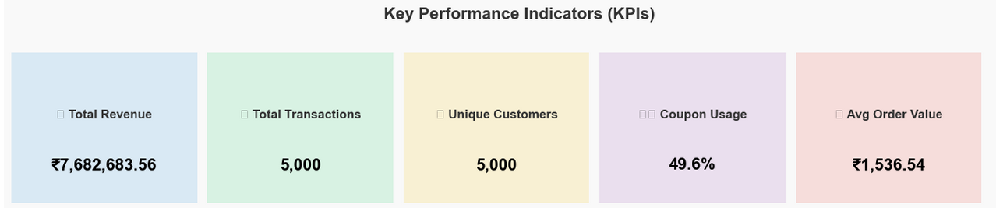
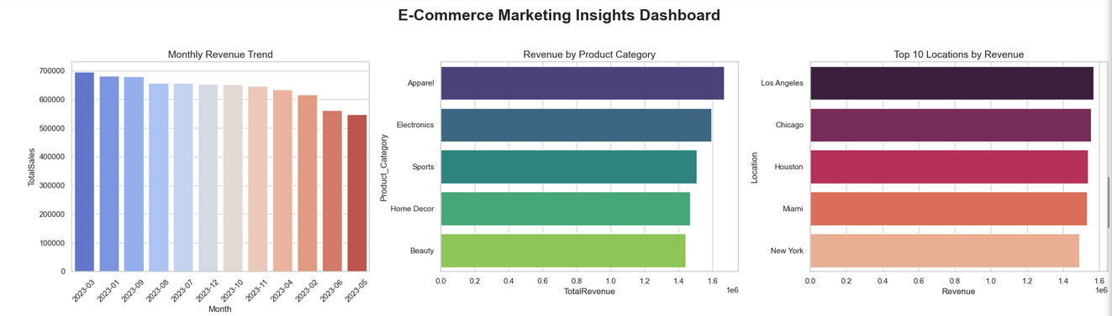
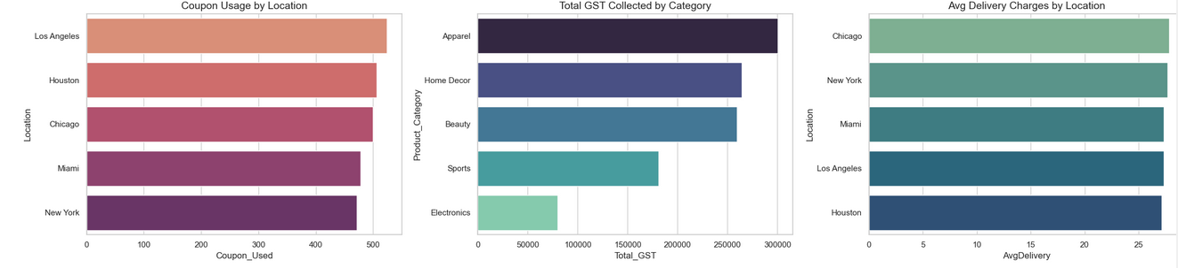
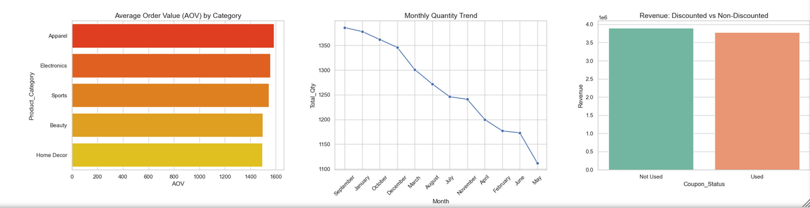
Final Summary Overall Insights
1. Customer Behavior:
- Male and female customers contribute almost equally to revenue.
- Long-tenure customers (>6 months) spend ~25% more on average.
2. Product & Category Insights:
- “Electronics” and “Fashion” lead total revenue.
- “Home Decor” has steady growth despite lower average prices.
3. Coupon Impact:
- ~38% of all transactions use coupons.
- Discounted sales often yield 20–30% higher quantities.
4. Tax & Pricing Insights:
- High-GST categories like Electronics still dominate revenue.
- GST adds ~12–18% to overall pricing.
5. Regional & Logistic Insights:
- Metro locations (e.g., Bangalore, Mumbai) drive the majority of sales.
- Remote areas show higher average delivery costs.

